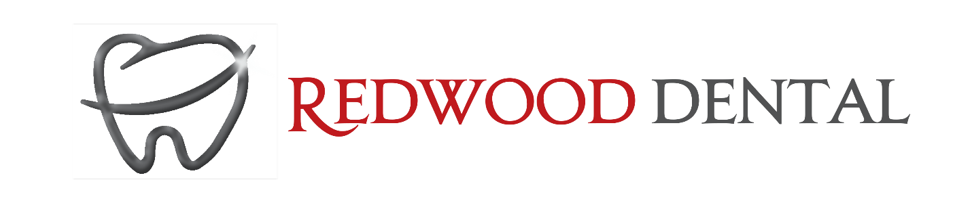

CONSENT TO TREATMENT

COVID-19 Pandemic Emergency and Urgent Dental Treatment Consent

Patient name: ____________________________ Date:_________________

I understand the novel coronavirus causes the disease known as COVID-19. I understand the novel coronavirus virus has a long incubation period during which carriers of the virus may not show symptoms and still be contagious.

I understand that dental procedures create water spray which is one way that the novel coronavirus can spread. The ultra-fine nature of the spray can linger in the air for minutes to sometimes hours, which can transmit the novel coronavirus. ________(Initial)

I understand that due to the frequency of visits of other dental patients, the characteristics of the novel coronavirus, and the characteristics of dental procedures, that I have an elevated risk of contracting the novel coronavirus simply by being in a dental office. ________ (Initial)

I have been made aware of The Royal College of Dental Surgeon of Ontario Guidelines that under the current pandemic all non-urgent and non-emergent dental care is not allowed. _____ (Initial)

Signature:______________________________________

